Gourmet Delights

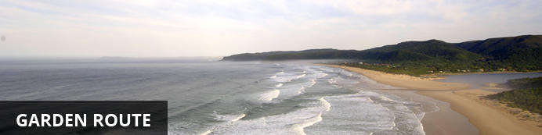
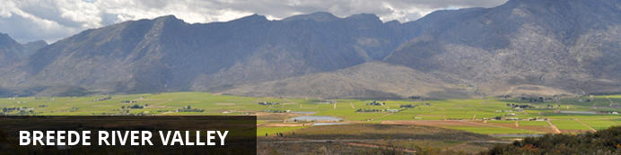
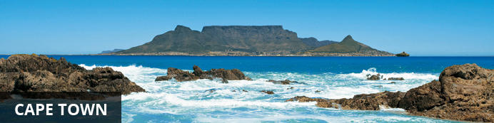

Gourmet Delights
Plettenberg Bay - Robertson - Constantia - Cape Town
11 Days / 10 Nights
Cost from £1,765.00 per person based on two sharing

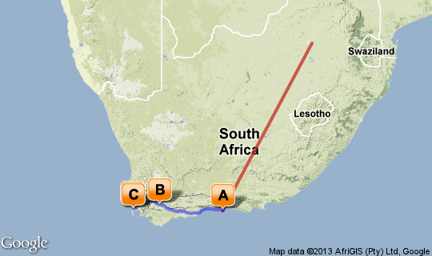

Click here to view your Virtual Itinerary

Overview
As a culinary destination South Africa is unrivalled, with Africa Travel able to offer the gourmet traveller a holiday featuring some of the country's finest food and wine experiences.

Destination | Accommodation | Nights | Basis | Room Type
Plettenberg Bay | The Plettenberg | 2 | B&B
Robertson | The Robertson Small Hotel | 2 | B&B
Constantia | The Cellars-Hohenort | 2 | B&B
Cape Town | Mount Nelson Hotel by Orient-Express | 2 | B&B

Key
B&B: Bed and breakfast. D, B&B: Dinner, bed and breakfast. FB: Dinner, bed, breakfast and lunch. FB+: Dinner, bed, breakfast, lunch and activities daily. FI: Fully inclusive.

Day 1: Travelling

Travelling

Days 2-4: The Plettenberg, Garden Route

Garden Route
With its great beaches along a narrow strip of fertile land nestled between majestic mountains and the big blue Indian Ocean the Garden Route is one of South Africa’s premier holiday destinations.

Overnight: The Plettenberg View iBrochure
The Plettenberg - situated on a rocky headland in Africa's most spectacular coastal resort - is the ultimate escape. The 37 luxury rooms and suites, showcase the most breathtaking vistas in Southern Africa. With views of the ocean, mountains and endless stretches of golden beach, The Plettenberg is situated in the heart of the adventure-rich Garden Route, world-renowned for its excellent selection of outdoor activities. From regular dolphin and whale sightings to bungee jumping, treetop canopy tours and other more daring pursuits in the surrounding countryside. The Plettenberg is the ideal place to both relax and unwind - or recharge and reinvigorate - through a series of sensational endeavours. At The Plettenberg the charming service and the setting combine to create the ultimate story, one of a South African seaside property unlike any other.
Services & Facilities: Air-conditioned rooms, restaurant, bar and lounge, car park, room service, security, Spa and Conference room.
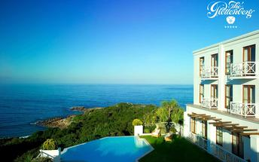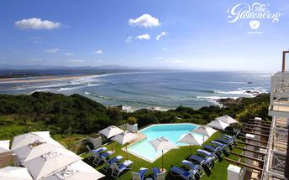

Included
Bed and Breakfast

Days 4-6: The Robertson Small Hotel , Breede River Valley

Breede River Valley
The Breede River Valley is home to some of South Africa's great wine producing areas and the partially navigable river offers the unique prospect of wine tasting while cruising along the calm waters.

Overnight: The Robertson Small Hotel
Chic sophistication meets Old World charm at The Robertson Small Hotel, a luxurious 5-star country retreat luring with unsurpassed comfort, exceptional service and a lavish splurge of genuine hospitality.
Each of the air-conditioned rooms is cocooned with its own unique celebration of modern design and fusion of eclectic yet comfortable furnishings whilst reflecting an appreciation for space. These deluxe suites not only provide solace for the soul, but are also fitted with the latest technology to cater for the needs of the trendy traveller and businessman.
Enhancing The Robertson Small Hotel experience, the Manor House is home to a cosy bar lounge, flaunting slick mirror, lead and pewter detail and a state-of-the-art wine cellar which lends a backdrop to the hotel’s signature restaurant, Reuben’s at the Robertson. Serving up culinary brilliance under the guidance of chef extraordinaire Reuben Riffel
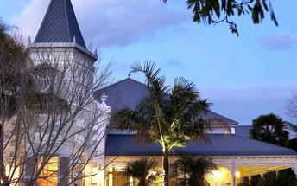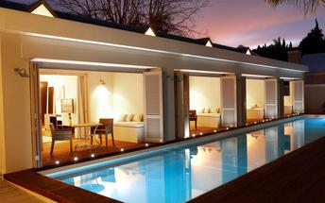

Included
Bed and Breakfast

Days 6-8: The Cellars-Hohenort, Cape Town

Cape Town
Cape Town is one of the world's most beautiful cities and a top international destination. Large volumes of tourist flock to Cape Town to enjoy this unique city with it's fascinating history, interesting culture, natural beauty, award winning wines and laidback lifestyle. Whether you are a serious tourist or just want to lie on the beach and enjoy life Cape Town will satisfy your needs.

Overnight: The Cellars-Hohenort View iBrochure
Located in the historical Constantia Valley, Cape Town, on the breath-taking slopes of Table Mountain The Cellars-Hohenort boasts 49 individually decorated rooms and suites. With panoramic mountain and garden views the owner-managed Cellars-Hohenort sets the scene for a fairytale stay. It is a must for those looking to add a delicious dose of peace and tranquillity to their life in the oldest winelands in “the cape” - a mere 15 minutes drive from the city centre and V&A Waterfront. Set on nine expansive acres of world-renowned gardens, this historic and beautiful country escape in the city offers guests far more than just incomparable scenery. A range of award-winning culinary offerings, a relaxing Fresh Wellness Spa and D&D Hair Salon, a Gary Player designed golf putting and chipping green, a tennis court and much more ensures that The Cellars-Hohenort is the result of Liz McGrath’s 20 years of hard work, love and endless inspiration. The Cellars-Hohenort has 3 very unique dining experiences. The Grand Chef flagship restaurant, The Greenhouse, The Conservatory and The Cape Malay Experience.
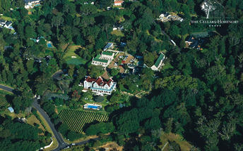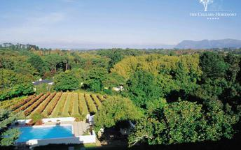

Included
Bed and Breakfast

Days 8-10: Mount Nelson Hotel by Orient-Express, Cape Town

Cape Town
Cape Town is one of the world's most beautiful cities and a top international destination. Large volumes of tourist flock to Cape Town to enjoy this unique city with it's fascinating history, interesting culture, natural beauty, award winning wines and laidback lifestyle. Whether you are a serious tourist or just want to lie on the beach and enjoy life Cape Town will satisfy your needs.

Overnight: Mount Nelson Hotel by Orient-Express View iBrochure
Set in the vibrant heart of Cape Town, Mount Nelson Hotel offers easy access to all that’s happening in this dynamic city.
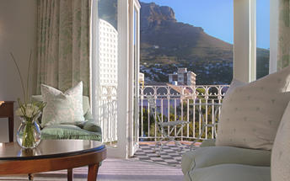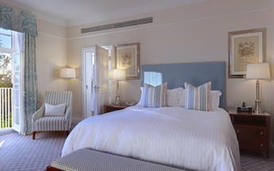

Included
Bed and Breakfast

Day 11: Travelling

Travelling

